Cherry Tomato Hearts

Ingredients
- Grape Tomatoes
- Toothpicks

Instructions
Slice the bottom of two grape tomatoes on an angle. Using a toothpick thread the two tomatoes together to form the shape of a heart. Serve with dip.
Recipe adapted from: http://www.recipebyphoto.com/cherry-tomato-hearts/

Veggie X’s & O’s
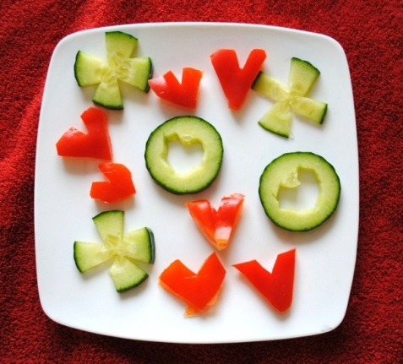
Ingredients
- Cucumber
- Red Pepper

Instructions
Cut cucumber creating round slices and carve a heart shape in the centre and/or carve the slice to form an X. Slice red pepper into 4-6 pieces. Carve pieces to form the shape of a heart. Serve with dip.

Recipe adapted from: http://www.pinterest.com/pin/510595676473114917/

Red Fruit Skewers

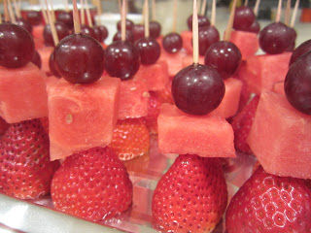
Ingredients
- Strawberries
- Watermelon
- Red Grapes
- Toothpicks

Instructions
Using a toothpick thread a strawberry, watermelon cube and grape to create a red fruit skewer.

Recipe adapted from:
http://fullplatecookinglessons.blogspot.ca/2012/02/healthy-valentines-snack-idea-mini-red.html

Apple Hearts
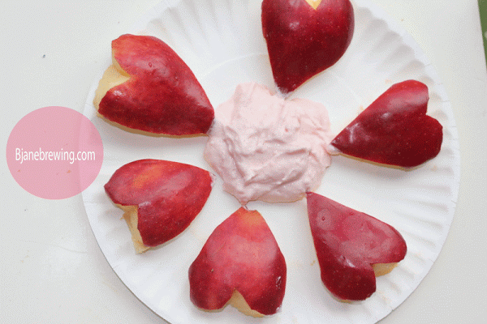
Ingredients
- Apples
- Strawberry or Raspberry Yogurt

Instructions
Slice apples into 4-6 pieces. Carve pieces to form the shape of a heart. Place on a plate and serve with strawberry or raspberry yogurt in the centre.

Recipe adapted from: http://www.bjanebrewing.com/2012/02/apple-hearts-ready-for-dunking.html

Healthy Hearts
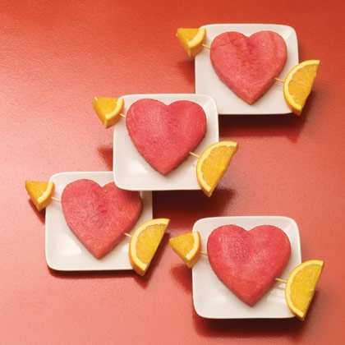
Ingredients
- Watermelon
- Orange
- Skewers

Instructions
Using a heart-shaped cookie cutter cut out watermelon slices. Poke a skewer through the heart. Complete the arrow with an orange slice tip and tail.

Recipe adapted from: http://spoonful.com/recipes/healthy-hearts

Your Very Own Valentine

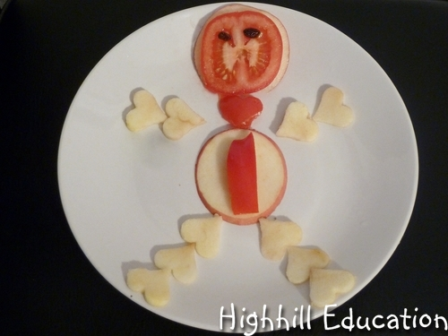
Ingredients
- Apple
- Strawberry
- Tomato
- Red Pepper
- Raisins

Instructions
Using a small heart-shaped cookie cutter cut out apple slices for arms and legs. Use a round apple slice to form an apple belly and apple head. Place a round tomato slice on top of the apple head. Use red pepper or strawberry pieces to form the neck and belly. Use two raisins to form the eyes.

Recipe adapted from:
http://highhillhomeschool.blogspot.de/2013/02/healthy-valentines-day-snacks-for-kids.html

Heart Kabobs

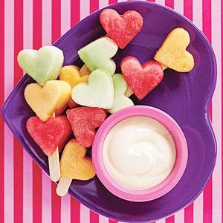
Ingredients
- 1 cantaloupe
- 1 honeydew melon
- ½ watermelon
- 1 six ounce container plain yogurt
- 1 tablespoon frozen orange-juice concentrate, thawed
- 1 tablespoon honey
- Ice-Pop Sticks

Instructions
Kabobs: Cut fruit into 1-inch-thick slices. Using a small heart-shaped cookie cutter, cut hearts from melon slices. Poke a hole in each heart with a toothpick, going from top to bottom. Thread fruit on ice-pop sticks.
Dip: Stir together yogurt, orange juice concentrate and honey until well combined. Serve with hearts.

Recipe adapted from: http://www.parents.com/recipe/desserts/heart-kabobs/

Dried Heart Strawberries

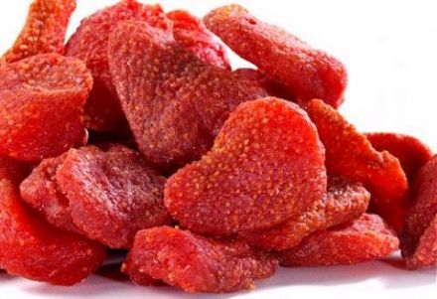
Ingredients
- Strawberries
- Salt and Pepper (optional)

Instructions
Halve or quarter strawberries, depending on their size. Place on a baking sheet. Lightly season with salt and pepper (optional). Dry in the oven for 3 hours at 100⁰C / 210⁰F to create dried heart strawberries.

Recipe adapted from: http://www.theworldwidegourmet.com/recipes/dried-strawberries-ruscalleda/

Raspberry Lemon Smoothie

Ingredients
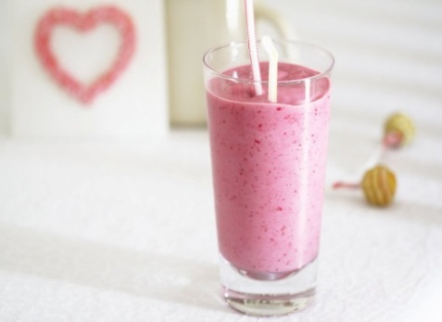
- 2 cups milk (2% or less)
- 2 cups frozen raspberries
- ½ cup lemon or vanilla flavored yogurt
- 2 tsp grated lemon zest
- 2 tbsp liquid honey

Instructions
In a blender, combine milk, frozen raspberries, yogurt, lemon zest and honey. Puree until smooth. Pour into
Image from: www.asplashofvanilla.com

glasses, serve immediately. Yields 2-4 servings.

Recipe adapted from: http://www.dairygoodness.ca/recipes/sensational-smoothies/(p)/preview

Strawberry Banana Smoothie
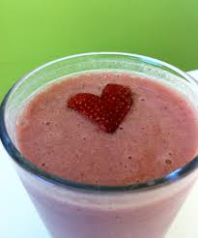
Ingredients
- 1 cup milk (2% or less)
- ½ cup frozen strawberries
- ½ banana
- 1/4 cup plain yogurt
- 1 tbsp liquid honey

Instructions

In a blender, combine milk, strawberries, banana, yogurt and honey. Puree until smooth. Pour into glasses, serve immediately. Yields 2 servings.
Image from: itsallabouttheflavour.tumblr.com/

Recipe adapted from: http://www.canadianliving.com/food/strawberry_banana_smoothie.php

Valentine Veggie Flowerpots

Ingredients
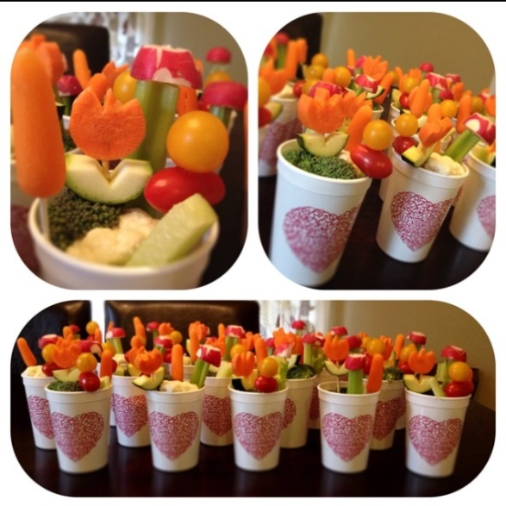
- Cucumber
- Celery
- Cauliflower
- Broccoli
- Carrots
- Grape Tomatoes
- Toothpicks or Skewers
- Reusable Plastic Cup

Instructions
Fill the bottom of the cup with pieces of cauliflower, broccoli, cumber slices and celery sticks. Using a toothpick or skewer, thread carrots, grape tomatoes and carved cucumber pieces to form flowers in a pot. Serve with dip.

Recipe adapted from: http://www.pinterest.com/pin/206954545346409606/

Valentine Fruit Platter

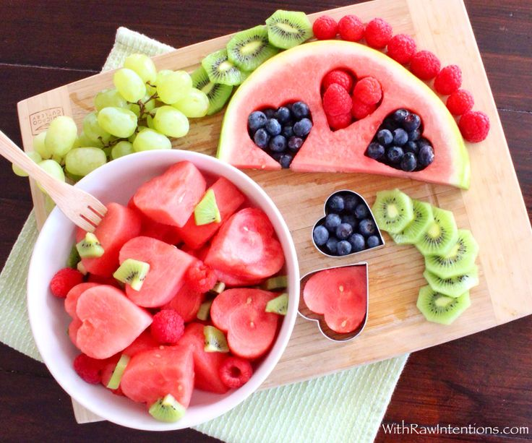
Ingredients
- Watermelon
- Green or Red Grapes
- Kiwi
- Strawberries and/or Raspberries
- Blueberries

Instructions
Slice watermelon into large pieces. Using a heart-shaped cookie cutter, cut out hearts and place in a bowl with strawberries and/or raspberries, kiwi pieces and grapes. Fill empty heart-shaped spaces of
watermelon slices with blueberries, strawberries
and/or raspberries.
Recipe adapted from: http://withrawintentions.com/

Fun Valentine Gift Ideas

Valentine Fruit Basket

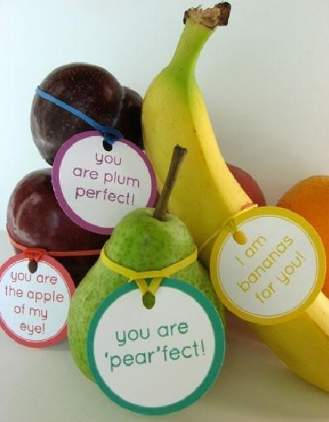
Instructions
Be creative and use a fun pun to go with your Valentine’s favourite fruit or vegetable.

Adapted from: http://alphamom.com/family-fun/holidays/free-printable-lunchbox-notes-tags-stickers/

You rule! Valentine’s Rulers

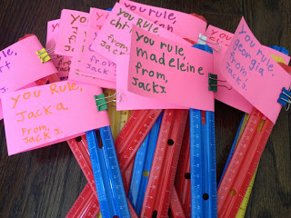
Instructions
Attach a Valentine card to a ruler that states “You Rule.” A fun non-food gift idea for the whole class!

Adapted from: http://www.fullplatecookinglessons.blogspot.ca/2013/02/you-rule-valentines.html

For more information or to share your Healthy Celebrations Ideas
please contact:

Krista Manning

School Health Promotion Liaison Consultant
Eastern Health & NLESD
Avalon East
kristamanning@esdnl.ca

Peggy Orbasli
School Health Promotion Liaison Consultant
Eastern Health & NLESD
Avalon West, Burin & Vista

peggyorbasli@esdnl.ca

Christina Tucker
Regional Nutritionist
Eastern Health
St. John’s and Area

christina.tucker@easternhealth.ca

Melissa Caravan
Regional Nutritionist
Eastern Health
Rural Avalon

melissa.caravan@easternhealth.ca

Last updated: Febuary 2014

