Valentine's Day Recipes

Tomato Heart and Cheese
(recipe adapted from parenting.com); (photo from ZiggityZoom .com)
Ingredients:
- Basil or Spinach leaves
- Cherry tomatoes
- Mozzarella balls or chunks
Instructions:
Arrange basil or spinach leaves on a plate in a heart shape. On top, place the cherry tomatoes in the shape of a heart. Fill center with mozzarella balls or chunks. Garnish with a celery leaf.

Hearty French Toast
(recipe adapted from parenting.com); (photo from ZiggityZoom .com)
Ingredients:
- Whole wheat bread
- Egg
- Skim milk
- Maple syrup (optional)
- Strawberries
Instructions:
Beat an egg in a low bowl. Add about ¾ cup milk per each egg used and stir. Using a heart-shaped cookie cutter, cut out heart shapes from the center of bread slices. Dip bread pieces into egg mixture and cook on medium heat until lightly brown. Garnish with cut strawberries and maple syrup (optional)

Lovely Banana Split
(adapted from http://school-bites.com/healthy-valentines-day-treats-school-party/)
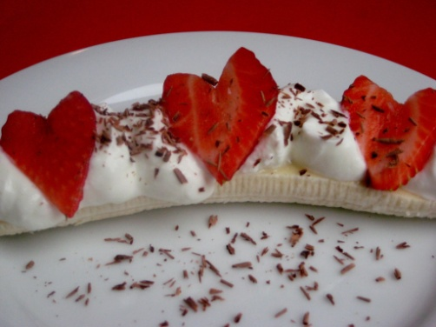
Ingredients:
- 1 banana
- 1 strawberry, washed and sliced
- 2 tbsp greek or plain yogurt
- Unsweetened dark chocolate (optional)
Instructions:
Place a peeled banana on a plate. Top with yogurt and strawberry slices. Grate a fine dust of dark chocolate on top using a carrot peeler or grater. Multiply the recipe to make one banana split per child.

Strawberry Spinach Salad
(adapted from allrecipes.com)
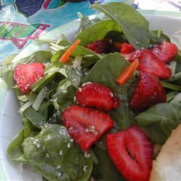
Ingredients:
- 2 tbsp sesame seeds
- 1 tbsp poppy seeds
- ¼ cup sugar
- ½ cup olive oil
- ¼ cup distilled white vinegar
- ¼ tsp paprika
- ¼ tsp Worcestershire Sauce
- 1 tbsp minced onion
- 10 ounces fresh spinach – washed, dried & torn into bite size pieces
- 1 quart strawberries, cleaned and sliced
- ¼ cup almonds, blanched and sliced
Instructions:
Whisk together the sesame seeds, poppy seeds, sugar, olive oil, vinegar, paprika, Worcestershire sauce and onion. Cover, and chill for one hour. In a large bowl, combine the spinach, strawberries and almonds. Add dressing, toss and refrigerate 10-15 minutes and then serve.

